Session 2026-2027

Session | 2026-27 |  | Course Name | Web Technology Lab
Semester | 3 |  | Course Code | 23CT1301
Roll No | A29 |  | Name of Student | Unnati Goyanka
Practical Number |  | 4B
Course Outcome |  | - Understand various internet technologies.  - Design the web pages using HTML and CSS.  - Implement the XML technology to store the data.  - Develop the interactive web pages using JavaScript.
Aim |  | To create an interactive To-Do List web application using HTML, CSS, and vanilla JavaScript, where users can add new tasks, mark tasks as completed, and delete tasks through DOM manipulation.
Problem Definition |  | A To-Do List helps users organize and track their daily activities. The purpose of this practical is to develop a simple web-based task management application. The application should provide an input box for entering tasks and allow users to perform different operations on each task. JavaScript DOM methods will be used to dynamically create task elements, add them to the webpage, change their status, and remove them. The application should respond immediately to user actions without refreshing the webpage.
Theory  (100 words) |  | The Document Object Model (DOM) provides a structured representation of an HTML webpage. JavaScript can use the DOM to access and modify webpage elements during program execution. In a To-Do List application, DOM manipulation is used to create task elements dynamically and display them on the screen. The createElement() method creates new HTML elements, while appendChild() places them inside another element. Event listeners detect actions such as button clicks. A CSS class can be added to indicate that a task is completed. The remove() method allows a selected task to be deleted. Thus, DOM manipulation makes the application interactive and responsive.
Procedure and Execution  (100 Words) |  | Step for Implementation:  • Create an HTML document with a heading, task input box, Add button, and task container.  • Design the interface using simple CSS.  • Select the required HTML elements using JavaScript DOM methods.  • Add a click event to the Add button.  • Read the task entered by the user.  • Create a new list item dynamically using createElement().  • Insert the task text into the newly created element.  • Create Complete and Delete buttons for every task.  • Attach click events to both buttons.  • Use the Complete button to change the task appearance.  • Use the Delete button to remove the task.  • Run and test the application with multiple tasks.
Code:

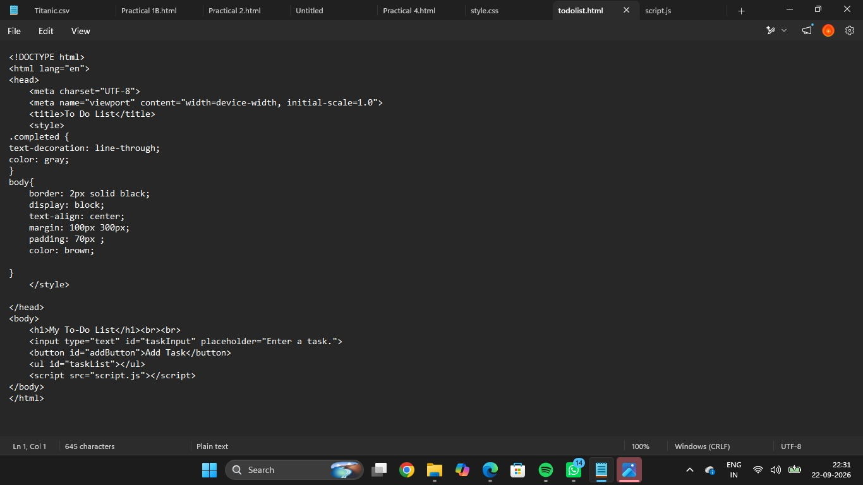

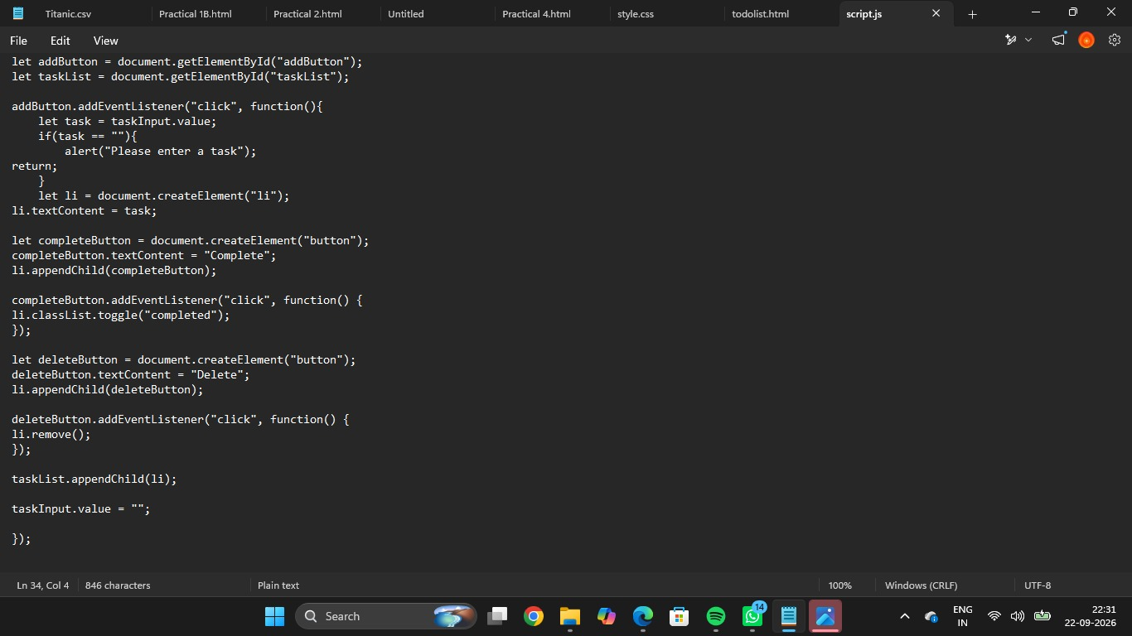

Output:
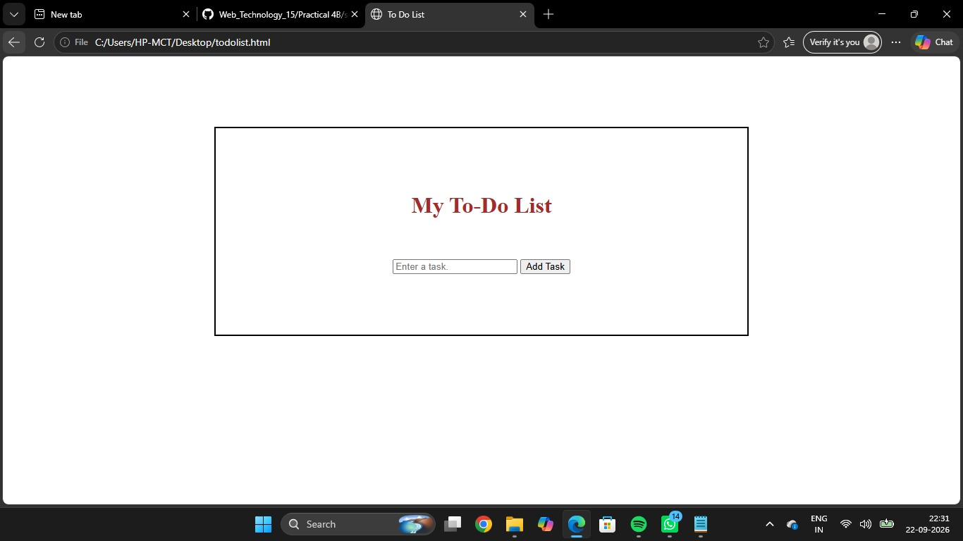

Output Analysis |  | The To-Do List application successfully creates tasks dynamically after the user enters task information. Each newly added task contains options for completing or deleting it. Selecting Complete visually changes the task to show that it has been finished. Selecting Delete removes the task from the list. The output demonstrates that JavaScript can dynamically control webpage content using DOM methods and event handling.
Link of student Github profile where lab assignment has been uploaded |  | https://github.com/palakgupta087654-cloud/Web_Technology_15/tree/main/Practical%204B
Conclusion |  | The To-Do List web application was successfully implemented using vanilla JavaScript and DOM manipulation. The practical provides an understanding of dynamically creating HTML elements, handling user events, modifying elements, and removing elements. It demonstrates how JavaScript can make a static webpage interactive without using external libraries or frameworks.
Plag Report (Similarity index < 12%) |  | The report content has been written in original wording for practical.
Date |  | 21/09/2026

